**CHAPTER 1**

**INTRODUCTION**

**1.1 Introduction**

In this paper, I explore whether there is mismanagement in the use of popular chemical fertilizers, despite years of experience by farmers, and if there is potential for productivity gains, using data from a field experiment in Bangladesh. The literature on technology adoption proposes numerous reasons why farmers may fail to adopt improved agricultural practices; lack of information, risk preferences, resource constraints and behavioral constraints such as limited attention may all result in sub-optimal behavior by farmers. Since the green revolution in the 1970s, Bangladesh has achieved considerable improvements in rice yields by adopting high-yielding varieties, expanding irrigation and increasing use of inputs including fertilizers. However, there are concerns that productivity gains from such changes are reaching its limits. Improving agricultural productivity remains an important objective to further reduce poverty; therefore, from a policy perspective it is important to understand whether there is scope for further improvements by changing the management of existing technology and inputs. This paper explores how farmers manage the use of urea, a nitrogen fertilizer that has been widely-used since the green revolution. In agriculture, it is particularly challenging to use inputs optimally. For each input, farmers have to learn about the right quantity, the correct timing and the proper method of application. The optimal application may also depend on other inputs, and vary by plot quality and weather. For urea in particular, the timing of the applications is very important in addition to quantity, which makes it easier to make mistakes. Unlike other fertilizers, urea needs to be applied several times during a season as it does not remain in the soil

Long due to it volatility. The timing of each of the applications is important as urea applied at the wrong time can have little or no effect on yields. Farmers may reduce wastage by applying urea when the crop can immediately take-up a lot of nitrogen, i.e. when there is shortage of nitrogen in the crop as can be identified from light green leaves. Crops that have sufficient nitrogen have dark green leaves. A leaf color chart (LCC) is a simple tool that indicates whether urea is needed by the crop. It is a plastic, ruler-shaped strip containing four panels that range in color from yellowish green to dark green, which can be used to determine if the crop has sufficient nitrogen, by matching the leaf color to the chart. Thus, it can help improve decisions on both quantity and timing. LCC is an effective tool as it provides simple rules and gives understandable signals on whether leaves are healthy or not in terms of nitrogen sufficiency. The intervention provided information and directed attention to the importance of timing of urea application and leaf colors. The availability of signals may also make it less risky for farmers to experiment and modify urea applications. It also provided very simple rules on when to apply urea. All of these factors can improve management of urea. The findings also show that in Bangladesh there is still significant scope for productivity gains by improving management of inputs within existing technology and resources.

**1.2 Literature Review**

**Agriculture of Bangladesh**

Bangladesh has a primarily agrarian economy. Agriculture is the single largest producing sector of the economy since it comprises about 30% of the country’s GDP and employs around 60% of the total labor force. The performance of this sector has an overwhelming impact on major macroeconomic objectives like employment generation, poverty alleviation, human resources development and food security.

Most Bangladeshis earn their living from agriculture. Although rice and jute are the primary crops, wheat is assuming greater importance. Tea is grown in the northeast. Because of Bangladesh’s fertile soil and normally ample water supply, rice can be grown and harvested three times a year in many areas. Due to a number of factors, Bangladesh’s labor-intensive agriculture has achieved steady increases in food grain production despite the often unfavorable weather conditions. These include better flood control and irrigation, a generally more efficient use of fertilizers, and the establishment of better distribution and rural credit networks. With 35.8 million metric tons produced in 2000, rice is Bangladesh’s principal crop. National sales of the classes of insecticide used on rice, including granular carbofuran, synthetic pyrethroids, and Malathion exceeded 13,000 tons of formulated product in 2003HYPERLINK  \l “cite_note-. The insecticides not only represent an environmental threat, but are a significant expenditure to poor rice farmers. The Bangladesh Rice Research Institute is working with various NGOs and international organizations to reduce insecticide use in rice.

In comparison to rice, wheat output in 1999 was 1.9 million metric tons. Population pressure continues to place a severe burden on productive capacity, creating a food deficit, especially of wheat. Foreign assistance and commercial imports fill the gap. Underemployment remains a serious problem, and a growing concern for Bangladesh’s agricultural sector will be its ability to absorb additional manpower. Finding alternative sources of employment will continue to be a daunting problem for future governments, particularly with the increasing numbers of landless peasants who already account for about half the rural labor force.

Rice and jute are the primary crops, maize and vegetables are assuming greater importance. Due to the expansion of irrigation networks, some wheat producers have switched to cultivation of maize which is used mostly as poultry feed. Tea is grown in the northeast. Because of Bangladesh’s fertile soil and normally ample water supply, rice can be grown and harvested three times a year in many areas. Due to a number of factors, Bangladesh’s labor-intensive agriculture has achieved steady increases in food grain production despite the often unfavorable weather conditions. These include better flood control and irrigation, a generally more efficient use of fertilizers, and the establishment of better distribution and rural credit networks. With 28.8 million metric tons produced in 2005-2006 (July-June), rice is Bangladesh’s principal crop.[4] By comparison, wheat output in 2005-2006 was 9 million metric tons. Population pressure continues to place a severe burden on productive capacity, creating a food deficit, especially of wheat. Foreign assistance and commercial imports fill the gap. Underemployment remains a serious problem, and a growing concern for Bangladesh’s agricultural sector will be its ability to absorb additional manpower. Finding alternative sources of employment will continue to be a daunting problem for future governments, particularly with the increasing numbers of landless peasants who already account for about half the rural labor force.

Bangladesh is the fourth largest rice  producing country in the world. National sales of the classes of insecticide used on rice, including granular carbofuran, synthetic pyrethroids, and Malathion exceeded 13,000 tons of formulated products in 2003. The insecticides not only represent an environmental threat, but are a significant expenditure to poor rice farmers. The Bangladesh Rice Research Institute is working with various NGOs and international organizations to reduce insecticide use in rice.

Wheat is not a traditional crop in Bangladesh, and in the late 1980s little was consumed in rural areas. During the 1960s and early 1970s, however, it was the only commodity for which local consumption increased because external food aid was most often provided in the form of wheat. In the first half of the 1980s, domestic wheat production rose to more than 1 million tons per year but was still only 7 to 9 percent of total food grain production. Record production of nearly 1.5 million tons was achieved in FY 1985, but the following year saw a decrease to just over 1 million tons. About half the wheat is grown on irrigated land. The proportion of land devoted to wheat remained essentially unchanged between 1980 and 1986, at a little less than 6 percent of total planted area Wheat also accounts for the great bulk of imported food grains, exceeding 1 million tons annually and going higher than 1.8 million tons in FY 1984, FY 1985, and FY 1987. The great bulk of the imported wheat is financed under aid programs of the United States, the European Economic Community, and the World Food Programmed.

Food grains are cultivated primarily for subsistence. Only a small percentage of total production makes its way into commercial channels. Other Bangladeshi food crops, however, are grown chiefly for the domestic market. They include potatoes and sweet potatoes, with a combined record production of 1.9 million tons in FY 1984; oilseeds, with an annual average production of 250,000 tons; and fruits such as bananas, jackfruit, mangoes, and pineapples. Estimates of sugarcane production put annual production at more than 7 million tons per year, most of it processed into a coarse, unrefined sugar known as gur, and sold domestically.

Wood is the main fuel for cooking and other domestic requirements. It is not surprising that population pressure has had an adverse effect on the indigenous forests. By 1980 only about 16 percent of the land was forested, and forests had all but disappeared from the densely populated and intensively cultivated deltaic plain. Aid organizations in the mid-1980s began looking into the possibility of stimulating small-scale forestry to restore a resource for which there was no affordable substitute.

The largest areas of forest are in the Chittagong Hills and the Sundarbans. The evergreen and deciduous forests of the Chittagong Hills cover more than 4,600 square kilometers and are the source of teak for heavy construction and boat building, as well as other forest products. Domesticated elephants are still used to haul logs. The Sundarbans, a tidal mangrove forest covering nearly 6,000 square kilometers along the Bay of Bengal, is the source of timber used for a variety of purposes, including pulp for the domestic paper industry, poles for electric power distribution, and leaves for thatching for dwellings.

Bangladesh being a first line littoral state of the Indian Ocean has a very good source of marine resources in the Bay of Bengal. The country has an exclusive economic zone of 41,000 square miles (110,000 km2), which is 73% of the country’s land area. On the other hand, Bangladesh is a small and developing country overloaded with almost unbearable pressure of human population. In the past, people of Bangladesh were mostly dependent upon land-based proteins. But, the continuous process of industrialization and urbanization consumes the limited land area. Now there is no other way than to harvest the vast under water protein from the Bay of Bengal, which can meet the country’s demand.

More than 80 percent of the animal protein in the Bangladeshi diet comes from fish. Fish accounted for 6 percent of GDP in the fiscal year of 1970, nearly 50 percent more than modern industrial manufacturing at that time. Most commercial fishermen are low-caste Hindus who eke out the barest subsistence working under primitive and dangerous conditions. They bring a high degree of skill and ingenuity to their occupation; a few of the most enterprising ones are aided by domesticated otters, which behave like shepherds, swimming underwater, driving fish toward the fisherman’s net (and being rewarded themselves with a share of the catch). Fish for local consumption are generally of freshwater varieties.

As of the end of 1987, prevailing methods for culturing shrimp in Bangladesh were still relatively unsophisticated, and average yields per hectare were low. In the late 1980s, almost all inland scrimping was done by capture rather than by intensive aquaculture. Farmers relied primarily on wild post larval and juvenile shrimp as their sources of stock, acquired either by trapping in ponds during tidal water exchange or by gathering from local estuaries and stocking directly in the ponds. Despite the seemingly low level of technology applied to shrimp aquaculture, it became an increasingly important part of the frozen seafood industry in the mid-1980s.

The World Bank and the Asian Development Bank financed projects to develop shrimp aquaculture in the 1980s. Private investors were also initiating similar projects to increase capacity and to introduce modern technology that would increase average yields.

Training for the fishing industry of Bangladesh, as well as for merchant shipping and related maritime industries is provided by the Bangladesh Marine Fisheries Academy.

**1.3 Leaf Color Charts**

The Leaf Color Chart (LCC) is a simple tool that allows farmers to understand whether urea is needed by the crop at any point in time during the urea application period. It is a plastic, ruler shaped strip containing four panels that range in color from yellowish green (nitrogen deficient) to dark green (nitrogen sufficient). As discussed above, rice farmers usually apply urea in several split applications during a season. With an LCC, before any application, farmers can compare the color of the paddy leaf to the chart to determine if nitrogen is needed. This allows for efficient urea application that is timed to when uptake by crops will be high. The instructions that accompany an LCC also tell farmers to first check 21 days after planting to determine if they should start applying urea, as the first three weeks are considered a period of higher wastage.

The literature on LCCs in agricultural journals usually finds an increase in returns either through substantial reduction in use of nitrogen fertilizers without any reduction in yields, or through substantial reduction in nitrogen fertilizers as well as improvements in yields. However, many of the studies are from demonstration plots which were closely supervised by agricultural workers. If farmers are given LCCs and basic training, it is not clear if they would choose to adopt and use LCCs and also whether they would be able to use them effectively. LCCs will only change urea use or yields if farmers are unable to learn how to time urea application well on their own, which they may have learned to do through experience.

**1.4 Purpose of Using Leaf Color Chart**

Leaf Color Chart (LCC) is an instant, easy and low cost technique for N diagnosis of current crop and N topdressing in crops. LCC an intelligent tool will help Rice, Maize & Wheat farmers to visually assess the need for nitrogen and apply the fertilizer. The color panels of the LCC are designed to indicate whether rice, maize, wheat plants are hungry or over-fed by nitrogen fertilizer. By matching the color of the rice, maize, wheat leaf to the color on the LCC, farmers can decide proper time and amount of N fertilizer for application. Leaf color chart ensure only need-based optimum use of chemicals in agriculture. Chemical fertilizer particularly urea is having indiscriminately applied to rice, maize and wheat in intrusively cultivated regions. There is an urgent need to rationalize the use of the urea and other nitrogenous fertilizer (organic and inorganic) in a way that these are applied as per the need of the crop by using Leaf Color Chat.

**1.5 LCC use in Paddy**

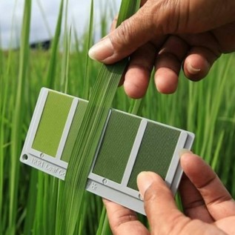

1. At 14days after transplanting (DAT) or 21 days after direct wet seeding (DAS), randomly select 10 healthy plants in your field where plant distribution is uniform.
2. Compare the topmost, fully expended, and healthy leaf of each of the 10 plants with the LCC. Place the middle part of the leaf on top of the LCC’s color strips for comparison. Do not detach the leaf. Take readings at same time of the day (8-10AM). Do not expose the LCC to direct sunlight during readings. The same person should take the first up to the last LCC reading.
3. Repeat LCC readings every 7 days for 110-130-day rice corps and every 10days for more than 130-day crops until first heading. Different sets of 10 leaves can be used for each weekly or 10-day reading.
4. If basal fertilizer with N is applied 0-14 DAT or 0-14 DAS, the first LCC reading is done at 21-25 DAT or 28-30 DAS instead of 14 DAT or 21 DAS.

**1.6 LCC use in Maize**

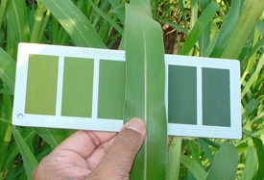

1. Apply 25kg Urea per acre at the time of showing of maize
2. Take reading of ten randomly selected maize plants, by matching the color of the first fully exposed leaf from the top with the leaf color chart (LCC) starting from 21days after sowing of maize till initiation of silking at 10 day interval.
3. Match the color of maize leaves with LCC shade 5. If 6 or more leaves out of 10 leaves are lighter than the specified threshold, apply 25kg urea per acre. When color of 5 or leaves is equal to or darker than the specified threshold no urea should be applied.
4. Always match the color or leaves with LCC in the shade of your body to avoid direct sunlight.
5. Use of LCC should be discontinued after silking in maize and no urea should be applied afterwards.

**1.7 LCC use in Wheat**

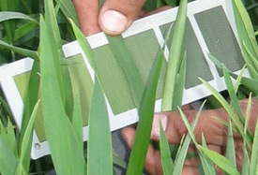

1. apply basal does 55kg di-ammonium phosphate (DAP) per acre.
2. Apply 40kg urea per acre for timely sown wheat and 25kg urea per acre for late sown wheat with first irrigation.
3. Match leaf color of youngest fully exposed leaf from the 10 randomly selected insect/disease free wheat plants from each field with LCC before 2nd irrigation.
4. If the greenness of 6 or more out of 10 leaves is less than shade 4 on LCC, broadcast 40kg urea per acre for timely sown wheat and 25kg urea per acre for late sown wheat with second irrigation.
5. If greenness is equal to or more than shade on LCC apply only 25kg urea per acre for timely sown wheat and 15kg urea per acre for late sown wheat with second irrigation.
6. Always compare color of the wheat leaf with LCC under shade of your body.

**1.8 Advantages of using LCC**

* Better Crops
* Avoid Diseases
* Fertilizer at Right Quantity at Right Time when Crops needs
* Save Money for Farmers
* Huge subsidy savings on N fertilizer for Govt.
* Reduce GHG Emission

**CHAPTER 2**

**SOFTWARE DEVELOPMENT LIFE CYCLE**

**Introduction:**

We know that the software development life cycle rotate as below:

**2.1 Image Sending and Processing Planning:**

Leaf Image

Raw Image

Filtered Image

Post Request

Process the Image

Cloud Processing

PHP Code in Server

Store Result in Server

**2.2 Flow Chart of Image Processing**

Image

Resize Image

Separate RAB

Send to the Analyzer

**2.3 Analyzer to Merge**

Analyzer

Red and Green

Find equal distance from centroids

Find equal distance from centroids

Red and Blue

Decision

Decision

Merge

Find equal distance from centroids

Decision

Green and Blue

**2.4 Merge to Result:**

Merge

Sample 1

Sample 3

Sample 4

Sample 2

Average

Write to result text

**2.5 Testing:**

Image

Analyzer

Store in text file

Red and Green Channel Centroids

Red and Blue Channel Centroids

Green and Blue Channel Centroids

Calculating total pixel count for every centroids (minimum distance)

Compare

Class 1

Class 2

Class 3

Class 4

Class 1

Output class

Find best match

Input

Output

**CHAPTER 3**

**METHODOLOGY**

**INTRODUCTION**

We live and work in a landscape that changes daily. New strategies and opportunities are emerging all the time. We hear of new technologies that promise ramped growth. However, growth is not the only thing we are concerned with anymore. We are hyper-focused on countering competitive threats, finding new and innovative ways to acquire customers and exploring strategies that foster increased customer loyalty and retention. We search for ways to bolster margins while decreasing costs. We are more than ever accountable for the risks we take daily, monthly and quarterly. All the while we are trying to optimize processes and increase productivity. Dropping the ball on any of these, means missing critical business goals, which can be devastating in today’s ultra-competitive environment. Growing your business means reacting to changing environments and circumstances. Even more importantly, it means actively planning and expecting to encounter a change in environment or circumstance and having the structure in place to react appropriately.

**3.1 IDE and Softwares:**

* Unity 3D for android application
* For testing application Unity remote is used
* Visual studio using C# for developing application
* Server side code Apache running on local server using PHP
* Image processing python 3 jupyter notebook
* File manipulation python 3
* Spider for IDE python
* Image segmentation using OpenCV
* Image processing Scikit Image
* Xampp

**3.2 Programming Languages:**

* PHP
* C#
* Python 3

**3.3 Server:**

* Localserver

**3.4 PHP:**

PHP is a great option for many reasons, so if you’re interviewing a company throwing around the PHP slag, here are some reasons why the language may be right for you or your project:

1. **Fast Load Time** – PHP results in faster site loading speeds. PHP codes runs much faster than ASP because it runs in its own memory space while ASP uses an overhead server and a COM based architecture.
2. **Less Expensive Software** – In working with PHP, most tools associated with the program are open source software, such as [WordPress](https://mayecreate.com/2013/12/6-reasons-why-wordpress-website/" \o "6 Reasons to Consider Using WordPress for Building Your Next Website), so you need not pay for them. As for ASP, you might need to buy additional tools to work with its programs.
3. **Less Expensive Hosting** – ASP programs need to run on Windows servers with IIS installed. Hosting companies need to purchase both of these components in order for ASP to work, this often results in a more expensive cost for monthly hosting services. On the other hand, a PHP would only require running on a Linux server, which is available through a hosting provider at no additional cost.

**3.5 C#:**

**C#** is a modern object-oriented programming language developed in 2000 by Anders Hejlsberg at Microsoft as a rival to Java (which it is quite similar to). It was created because Sun, (later bought by Oracle) did not want Microsoft to make changes to Java, so Microsoft chose to create their own language instead.

**3.6 Python 3:**

**Python** is a high-level, interpreted and general-purpose dynamic programming language that focuses on code readability. The syntax in **Python** helps the programmers to do coding in fewer steps as compared to Java or C++. ... The **Python** is widely used in bigger organizations because of its multiple programming paradigms.

**CHAPTER 4**

**SYSTEM DESIGN OVERVIEW**

**4.1 Data Flow Diagram**

Cloud computer

Application

Image captured with green shade of leaf

Smart Phone

4x Image

Capture

Image segmentation

Find minimum distance with centroid

Resizing the image

Image 3

Image 4

Image 2

Image 1

Analyzer

Result

Result

Internet

**4.2 Overall System**

Leaf Image

Raw Image

Filtered Image

Post Request

Process the Image

Cloud Processing

PHP Code in Server

Store Result in Server

**CHAPTER 5**

**PROJECT IMPLEMENTATION**

**5.1 Taking Red and Green**

**Class 1**

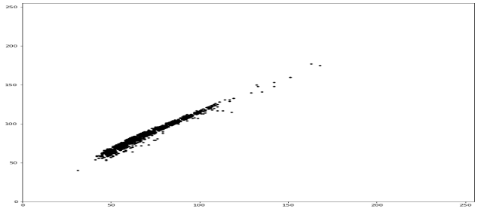

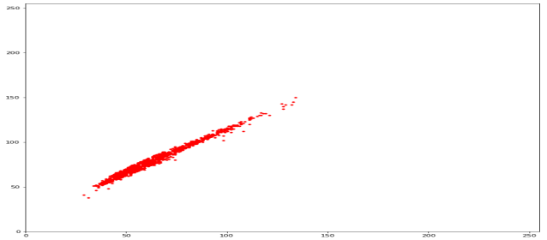**Class 2**

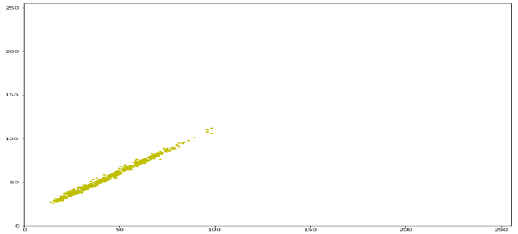**Class 3**

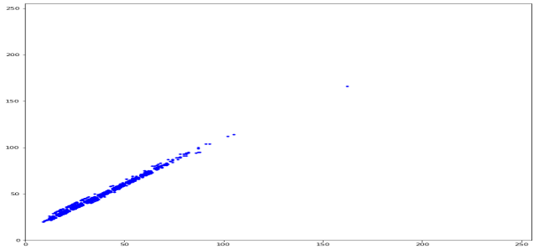

**Class 4**

**Kmean algorithm**

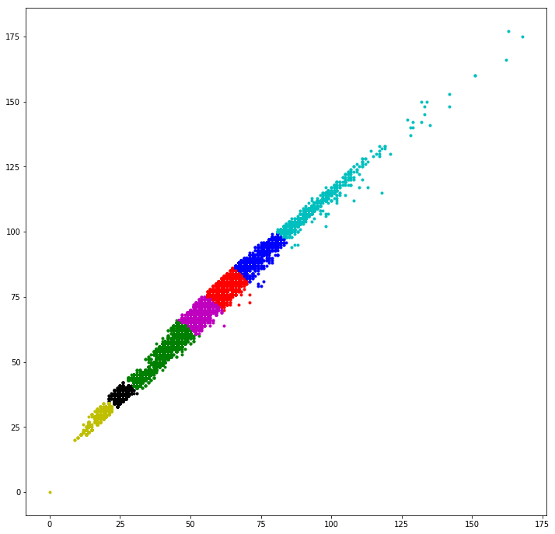

**Centroids point:**

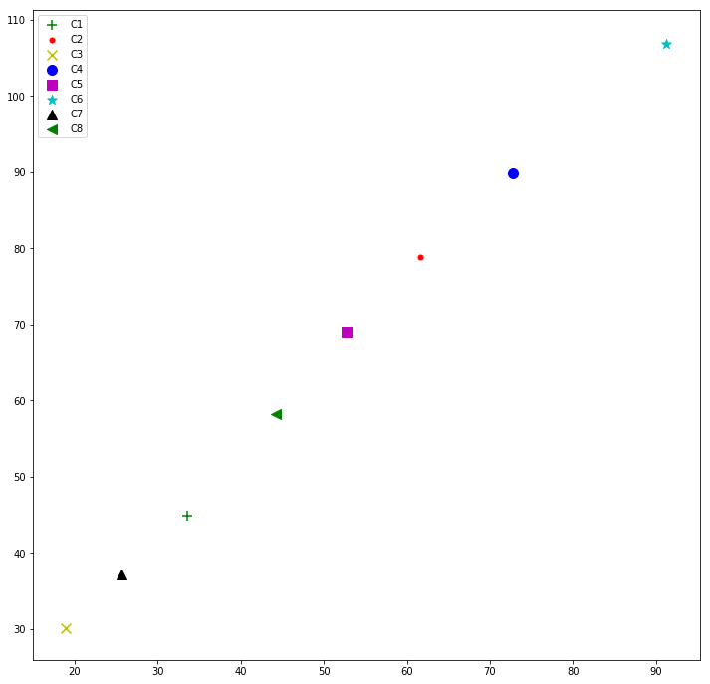

**Class 1 centroid count:**

C1 = 1

C2 = 3672

C3 = 1

C4 = 3195

C5 = 2097

C6 = 828

C7 = 0

C8 = 206

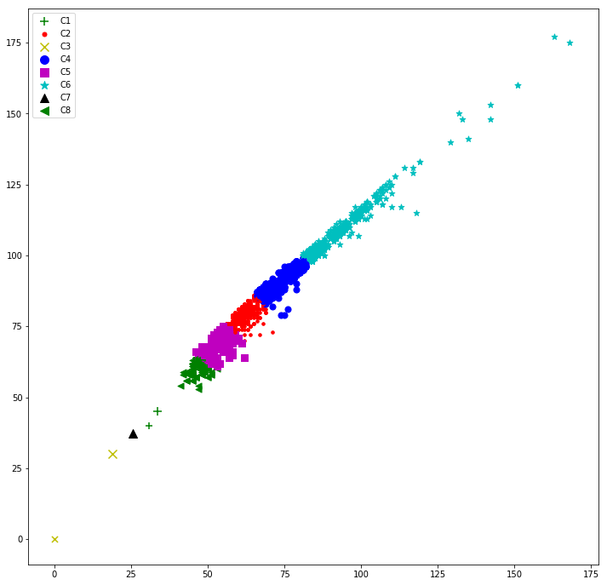

**Class 2 centroid count**

C1 = 25

C2 = 2108

C3 = 1

C4 = 941

C5 = 3814

C6 = 379

C7 = 2

C8 = 2731

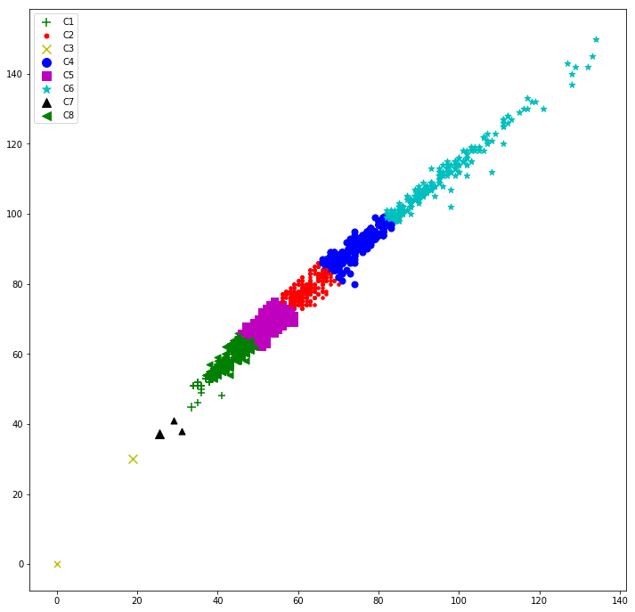

**Class 3 centroid count**

C1 = 3253

C2 = 178

C3 = 1358

C4 = 49

C5 = 393

C6 = 7

C7 = 3358

C8 = 1405

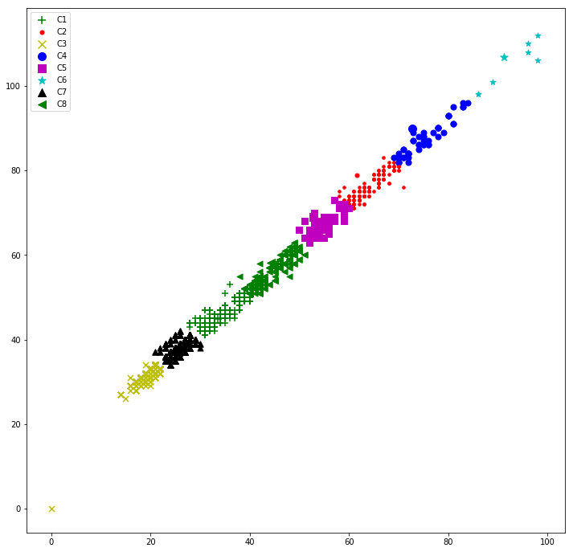

**Class 4 centroid count**

C1 = 2146

C2 = 86

C3 = 3657

C4 = 33

C5 = 196

C6 = 10

C7 = 3338

C8 = 535

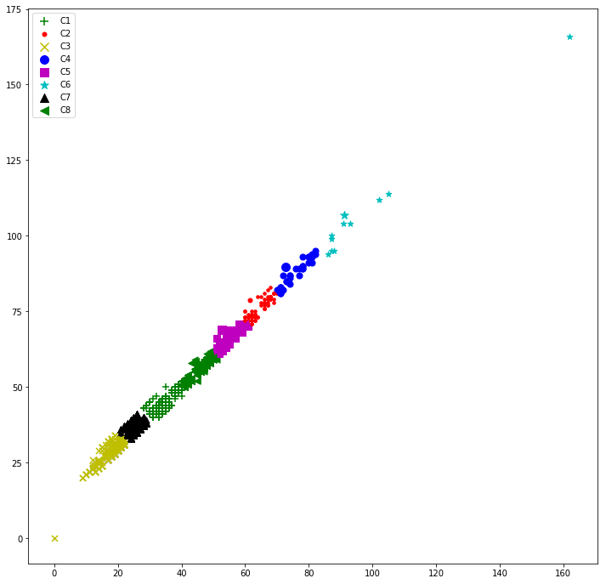

**5.2 Taking red and blue**

**Class 1**

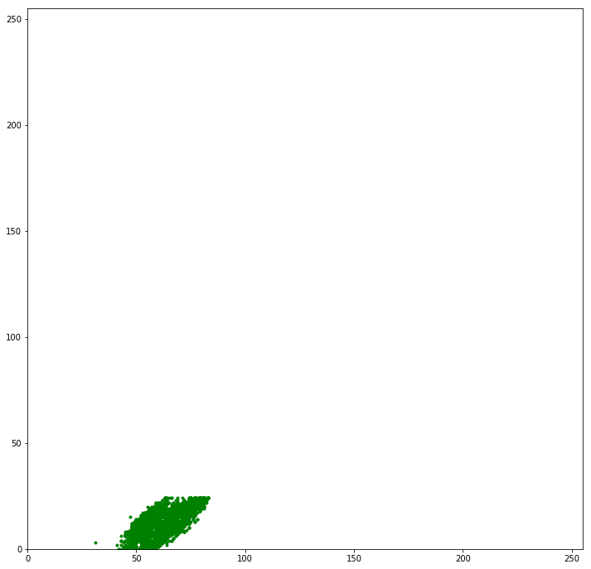

**Class 2**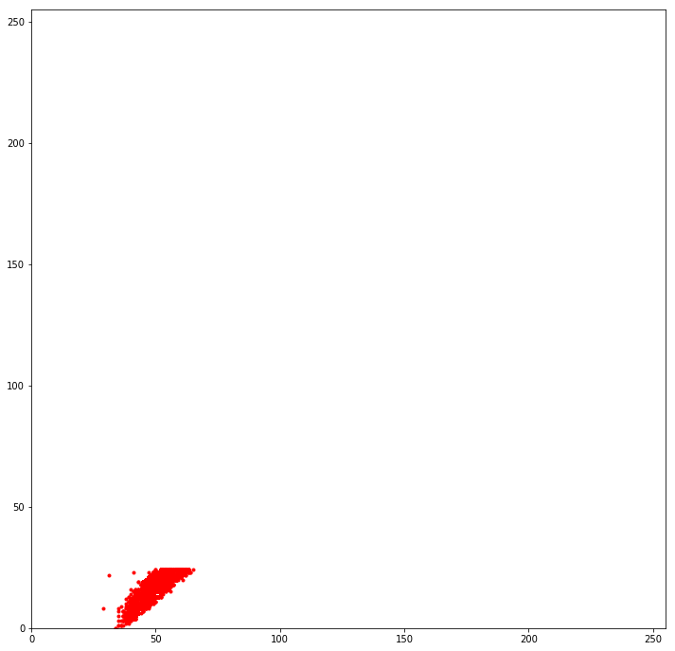

**Class 3**

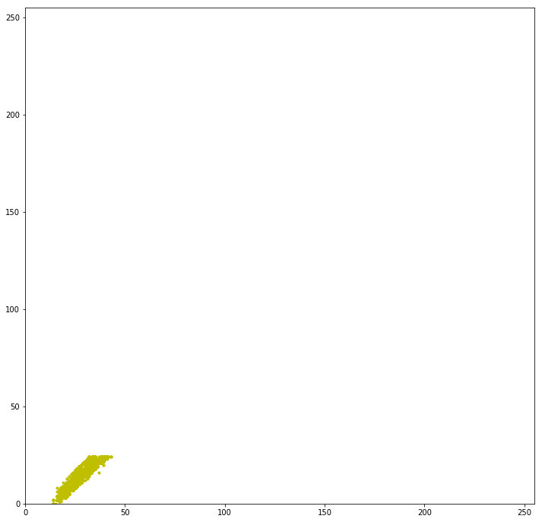

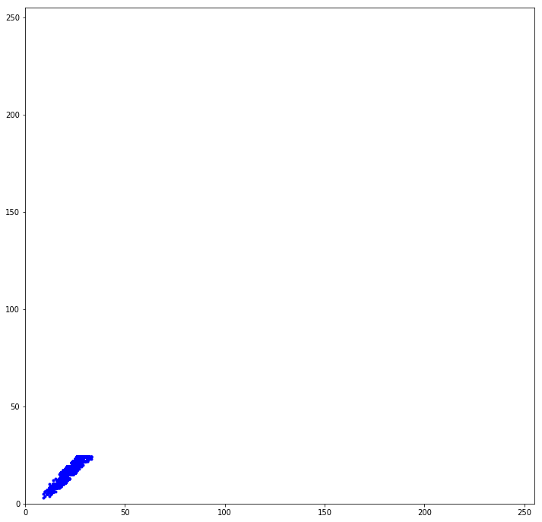**Class 4**

**K mean Centroids area**

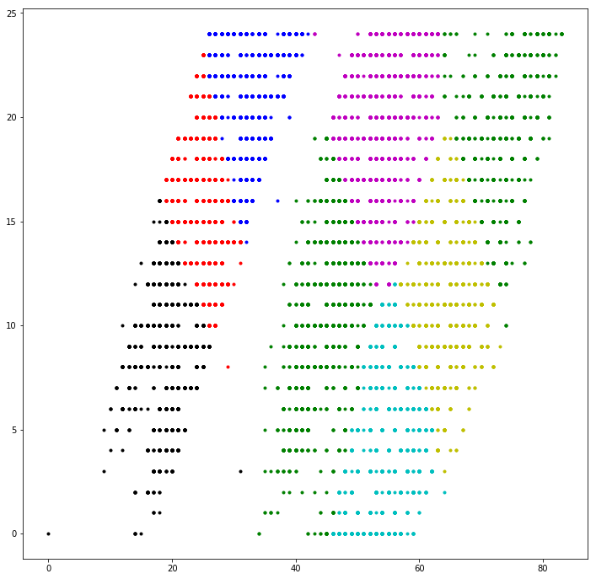

**Centroid point**

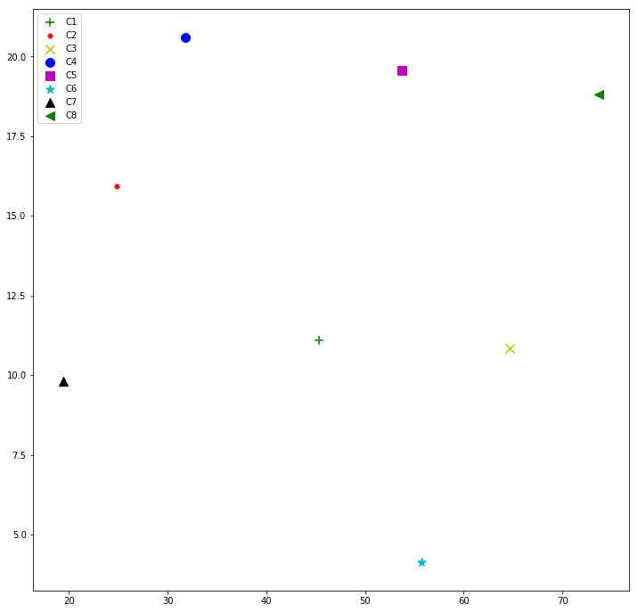

**Class 1 centroid count**

C1 = 260

C2 = 0

C3 = 3129

C4 = 0

C5 = 362

C6 = 3146

C7 = 2

C8 = 1992

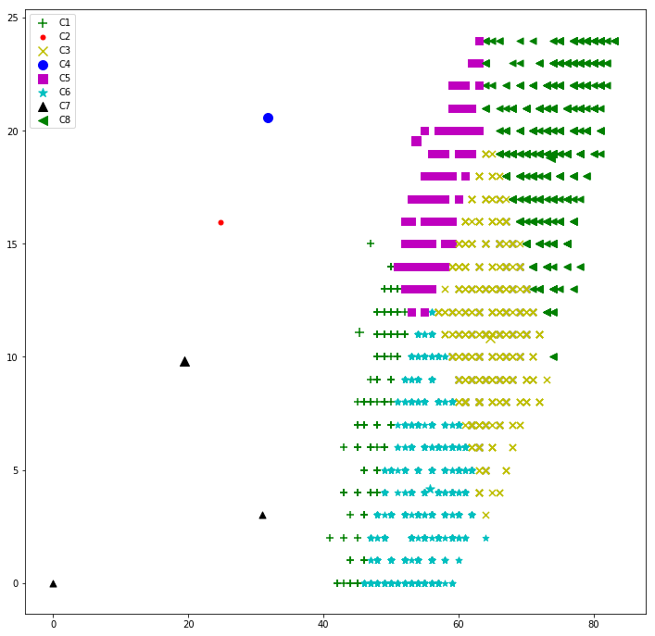

**Class 2 centroid count**

C1 = 3181

C2 = 1

C3 = 0

C4 = 2

C5 = 3542

C6 = 0

C7 = 1

C8 = 3

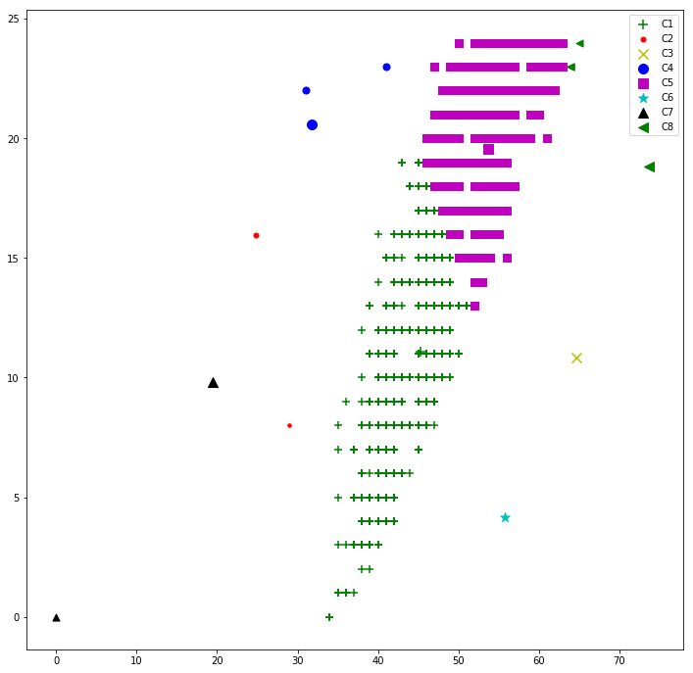

**Class 3 centroid count**

C1 = 0

C2 = 2553

C3 = 0

C4 = 3001

C5 = 3

C6 = 0

C7 = 2223

C8 = 0

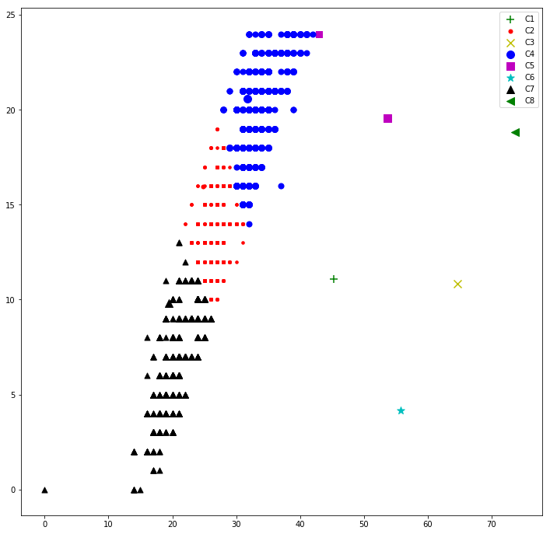

**Class 4 centroid count**

C1 = 0

C2 = 3123

C3 = 0

C4 = 1367

C5 = 0

C6 = 0

C7 = 2726

C8 = 0

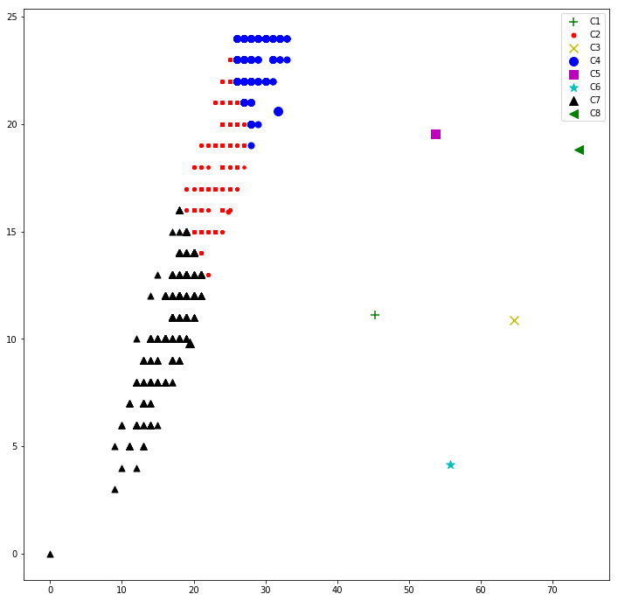

**5.3 Taking Green and Blue**

**Class1**

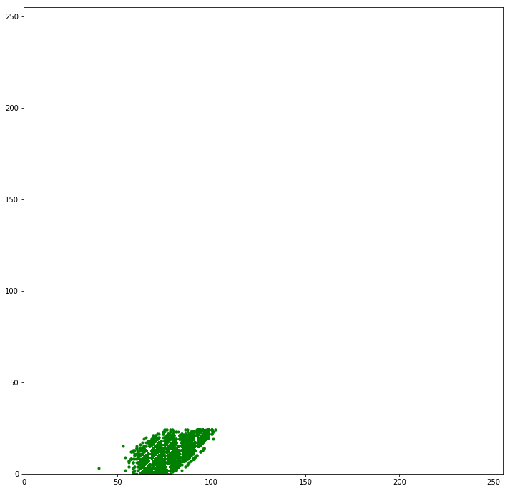

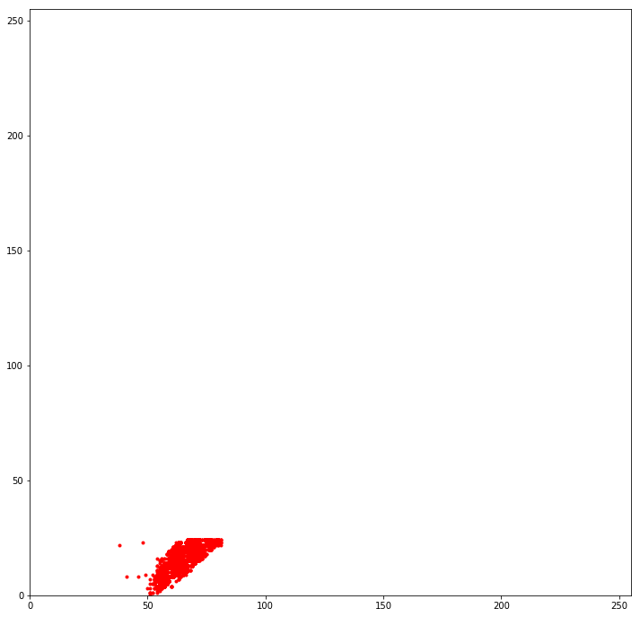**Class2**

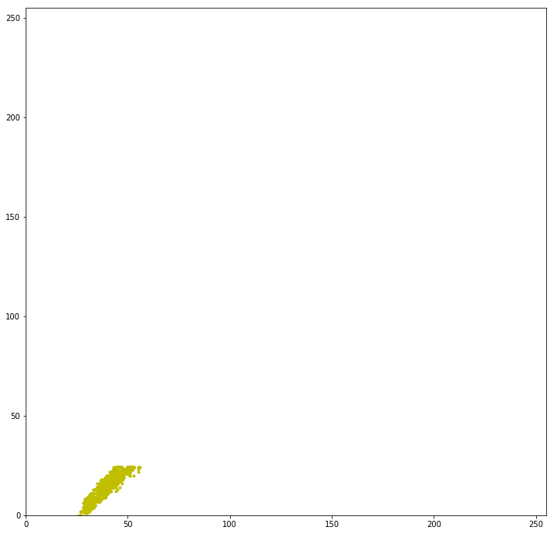**Class3**

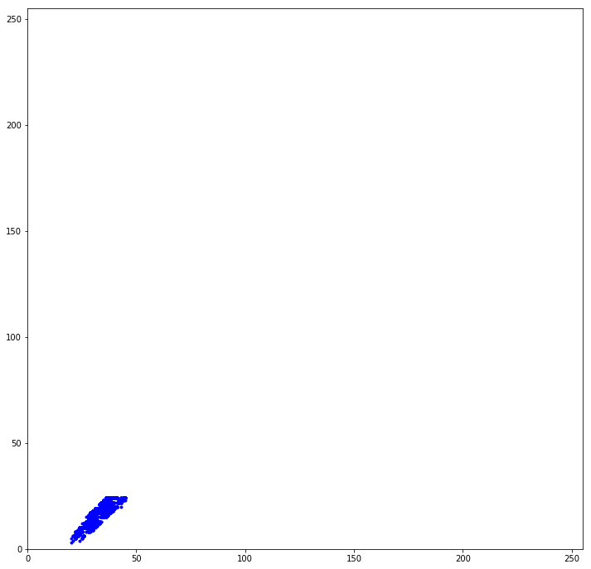**Class 4**

**Kmean centroids**

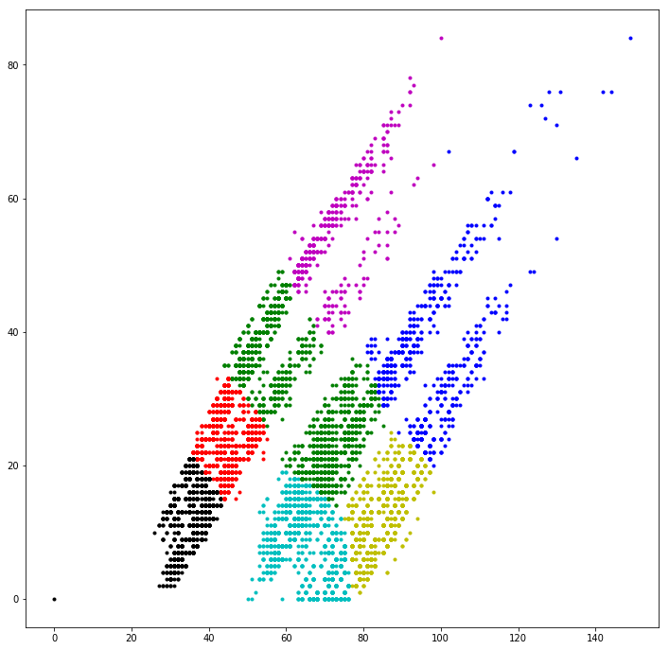

**Centroids point**

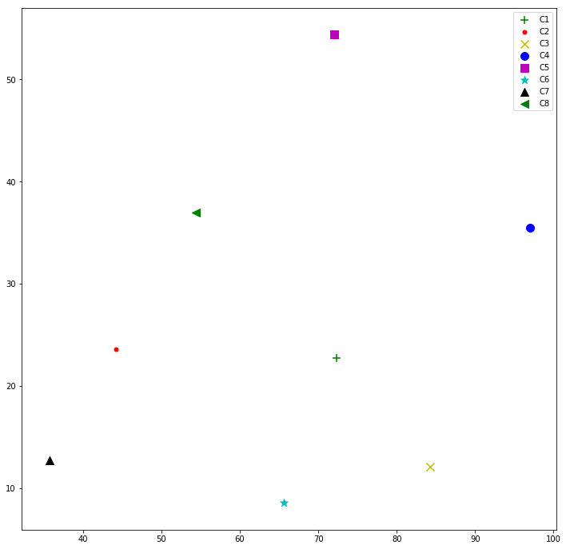

**Class 1 centroid count**

C1 = 67

C2 = 0

C3 = 1412

C4 = 331

C5 = 0

C6 = 690

C7 = 1

C8 = 0

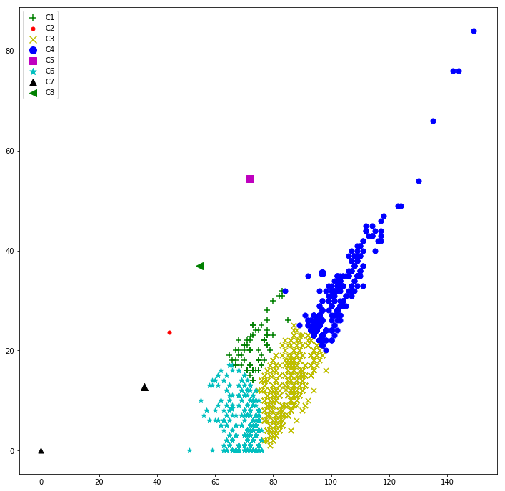

**Class 2 centroid count**

C1 = 1282

C2 = 0

C3 = 0

C4 = 379

C5 = 0

C6 = 839

C7 = 1

C8 = 0

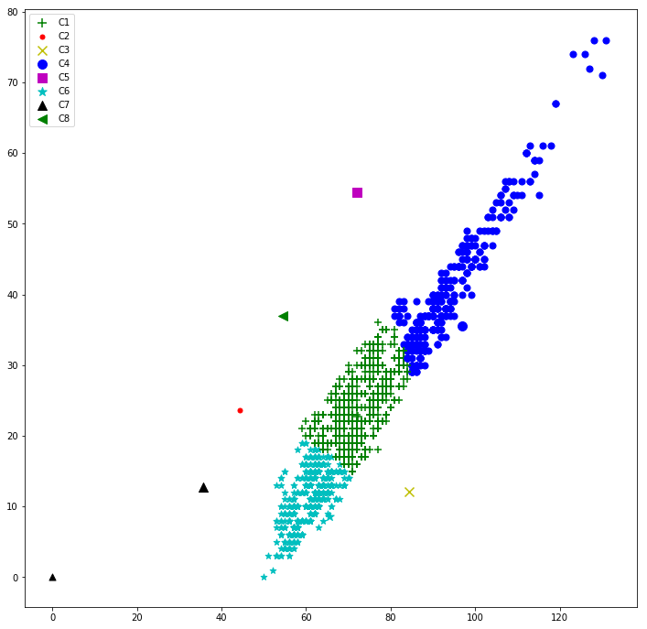

**Class 3 centroid count**

C1 = 0

C2 = 886

C3 = 0

C4 = 1

C5 = 74

C6 = 0

C7 = 1243

C8 = 297

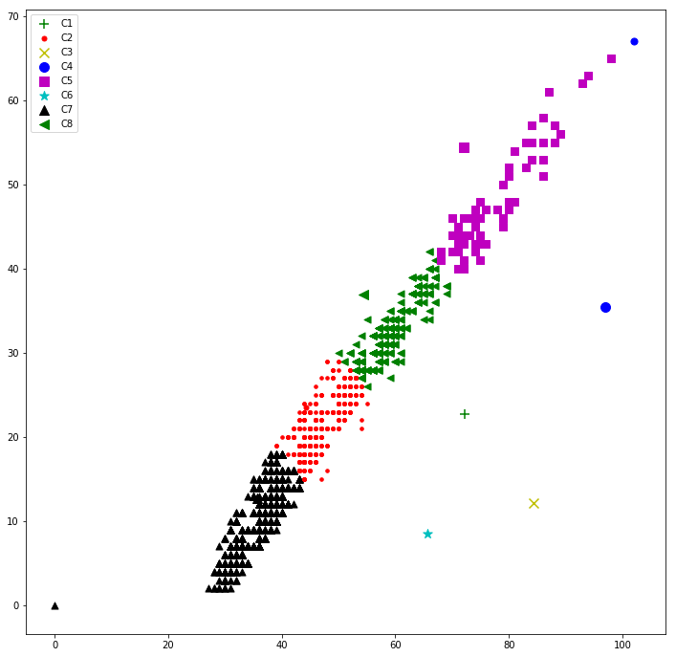

**Class 4 centroid count**

C1 = 0

C2 = 852

C3 = 0

C4 = 0

C5 = 347

C6 = 0

C7 = 585

C8 = 717

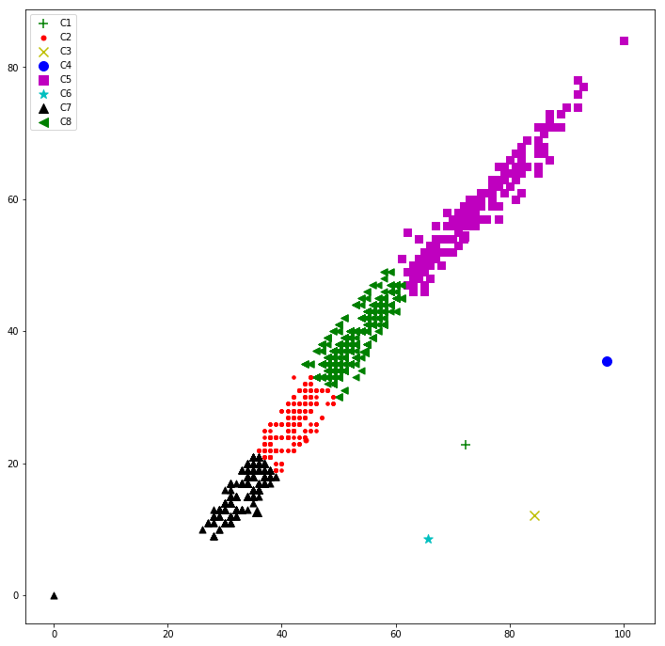

**5.4 Input image to the analyzer**

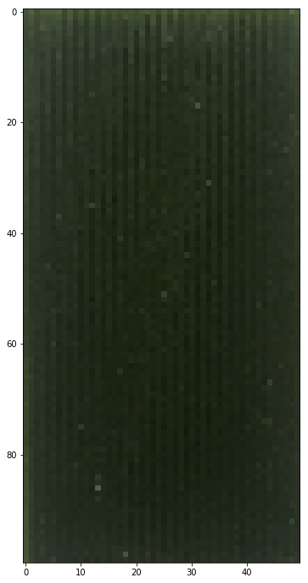

**Centroids count for red and green pixel:**

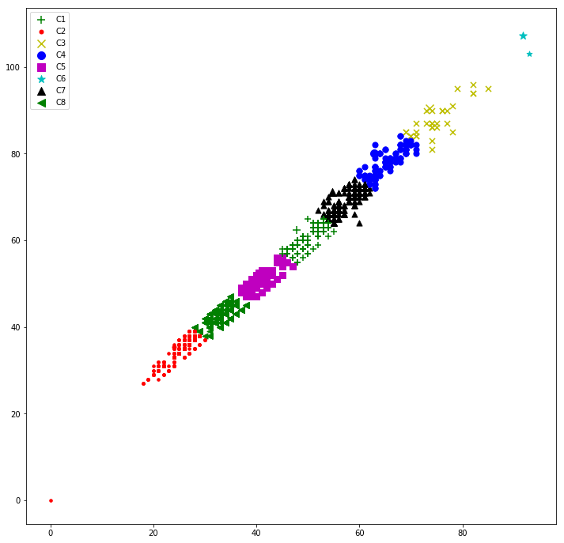

**Centroids count for red and blue pixel:**

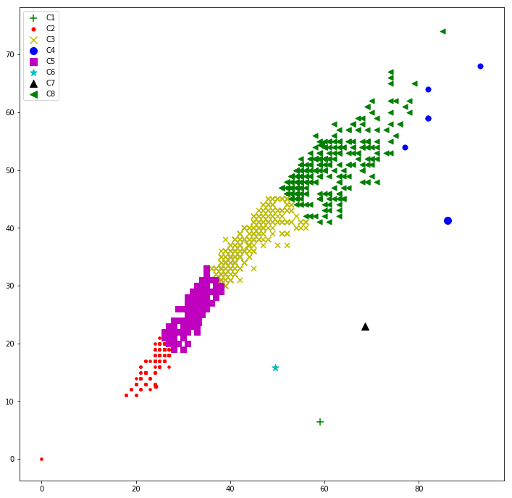

**Centroids count for green and blue pixel:**

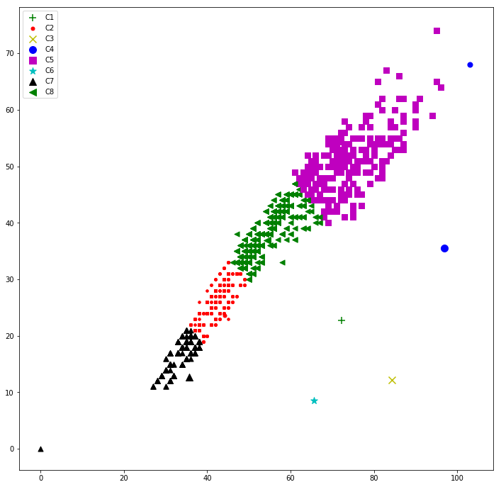

**Output**

Sum RG : [0.14168833753600002, 0.109038845952, 0.0020931069759999987, 0.0009456919199999996]

Red and Green : 3

Sum RB : [0.34012618627999996, 0.451446573608, 0.05615836229600003, 0.0031176063460292757]

Red and Blue : 3

Sum GB : [0.324513824264, 0.29710488730400003, 0.029392970423999992, 0.0017341099919999997]

Green and Blue : 3

**CHAPTER 6**

**DATA TABLE**

|  |  |  |  |  |  |  |  |  |  |  |
| --- | --- | --- | --- | --- | --- | --- | --- | --- | --- | --- |
| Class | Total Pixel | Taken Pixel1 | C3 | C7 | C1 | C8 | C5 | C2 | C4 | C6 |
| Class 1 | 10000 | 9999 | =1  =.00010001 | 0 | =1  =.00010001 | =206  =.02060206021 | =2097  =.2097209721 | =3672  =0.367237 | =3195  =.3195319532 | =828  =.8280828083 |
| Class 2 | 10000 | 10000 | =1  =.00010001 | =2  =0.002 | =<5  =0.0025 | =2731  =0.2731 | =3814  =.3814 | =2108  =0.2108 | =341  =0.0341 | =379  =.0379 |
| Class 3 | 10000 | 10000 | =1358  =0.1358 | =3358  =.3358 | =3253  =0.3253 | =1405  =.1405 | =393  =0.0393 | =178  =0.0178 | =49  =.0049 | =7  =.0007 |
| Class 4 | 10000 | 10000 | =3657  =.3657 | =3336  =3338 | =2146  =0.2146 | =535  =0.0535 | =196  =.0196 | =86  =0.0086 | =33  =.0033 | =10  =.001 |

**C5**

**C4**

**C8**

**C1**

**C3**

**C6**

**C7**

**C2**

**Red and Green**

|  |  |  |  |  |  |  |  |  |  |  |
| --- | --- | --- | --- | --- | --- | --- | --- | --- | --- | --- |
| Class | Total Pixel | Taken Pixel1 | C5 | C1 | C3 | C4 | C8 | C7 | C2 | C6 |
| Class 1 | 10000 | 8890 | =0 | =2  =.0002249 | =0 | =312  =.03509561305 | =2597  =.2921259843 | =2416  =.2727660292 | =3229  =0.3632170973 | =335  =.03768278965 |
| Class 2 | 10000 | 6729 | =1  =0.0001486 | =2  =.00029722 | =3  =000415831 | =3265  =.4652132 | =0 | =7  =.001040273 | =0 | =3452  =0.513003418 |
| Class 3 | 10000 | 7779 | =2002  =.2573595578 | =2736  =.3517161 | =3042  =.3910528346 | =0 | =0 | =0 | =0 | =0 |
| Class 4 | 10000 | 100077215 | =3485  =.483021483 | =3336  =.4669438669 | =362  =.05017325017 | =0 | =0 | =0 | =0 | =0 |

**Green and Blue**

**C6**

**C3**

**C7**

**C4**

**C2**

**C8**

**C1**

**C5**

|  |  |  |  |  |  |  |  |  |  |  |
| --- | --- | --- | --- | --- | --- | --- | --- | --- | --- | --- |
| Class | Total Pixel | Taken Pixel1 | C4 | C2 | C7 | C5 | C1 | C8 | C3 | C6 |
| Class 1 | 10000 | 8890 | =0 | =0 | =2  =.00024971 | =362  =.0.0471991 | =260  =.0292464 | =1992  =0.224071991 | =3122  =.3519685039 | =3145  =.353768279 |
| Class 2 | 10000 | 6729 | =2  =.0002722 | =1 | =1  =.0001486 | =3542  =0.5263883 | =3181  =.472581 | =3  =.000445831 | =0 | =0 |
| Class 3 | 10000 | 7779 | =3001  =.385782234 | =2553  =0.328191 | =2223  =0.2857693791 | =3  =.000385653 | =0 | =0 | =0 | =0 |
| Class 4 | 10000 | 7215 | =1367  =.1894663875 | =3123  =0.4328482328 | =2726  =.3778239778 | =0 | =0 | =0 | =0 | =0 |

**C5**

**C4**

**C8**

**C1**

**C3**

**C6**

**C7**

**C2**

**Red and Blue**

**CHAPTER 7**

**FUTURE RESEARCH**

**7.1 RESEARCH METHOD**

Process of finding the best model relation between every class with the Red channel and Green channel pixel with HSV (Heu, Saturation, Value).

**Image 1 (Class 1)**

Taking Hue and Red Pixel

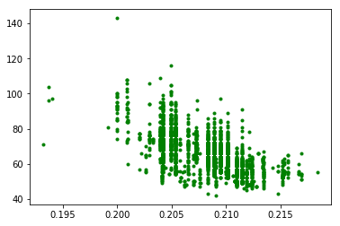

**Image 2 (Class 1)**

Taking Saturation and Red

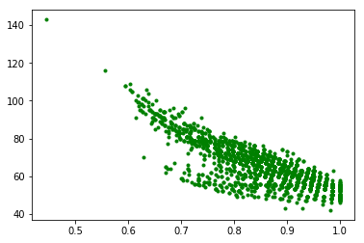

**Image 3 (Class 1)**

Taking Value and Red

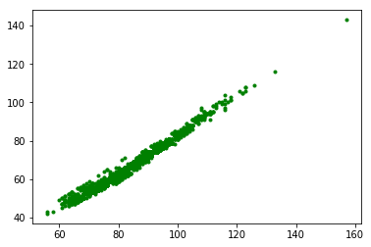

**Image 4 (Class 1)**

Taking Heu and Green

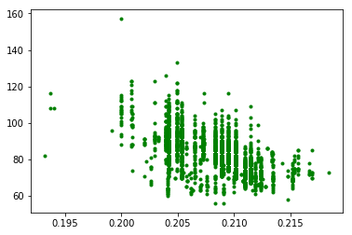

**Image 5 (Class 1)**

Taking Saturation and Green

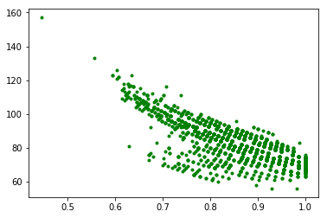

**Image 6 (Class 1)**

Taking Value and Green

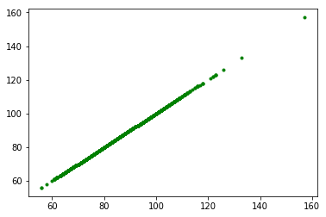

**Image 7 (Class 2)**

Taking Hue and Red

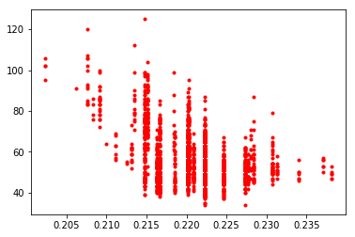

**Image 8 (Class 2)**

Taking Saturation and Red

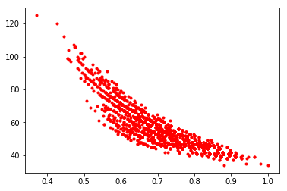

**Image 9 (Class 2)**

Taking Value and Red

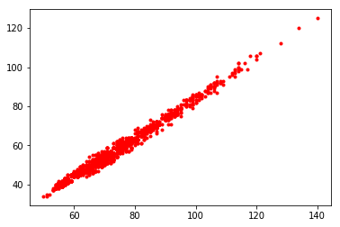

**Image 10 (Class 2)**

Taking Hue and Green

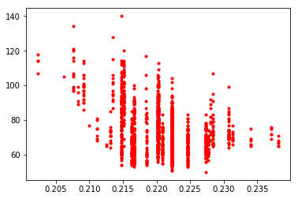

**Image 11 (Class 2)**

Taking Saturation and Green

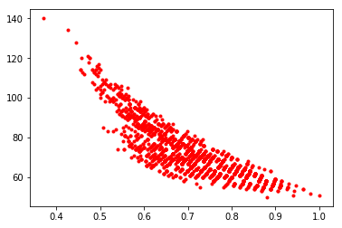

**Image 12 (Class 2)**

Taking Value and Green

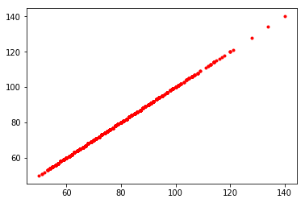

**Image 13 (Class 3)**

Taking Hue and Red

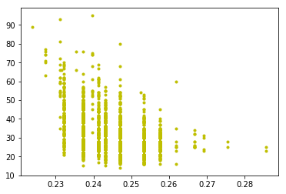

**CHAPTER 8**

**RESULT AND DISCUSSION**

**Result**

How much fertilizer is needed for crop per hector ,waste free fertilization ,easy fertilization, less water pollution, large scale farm handling will be easy using this application with cloud processing.

**Recommendation**

I want to say, our agriculture sector developing day by day. Our agriculture products are more demanded day by day in foreign market. It’s remove our unemployment. Agriculture sector keeps important role in our country. It is unfortunate for the peasants of our country that they work hard for agriculture products but get very poor output. It is the first & foremost duty to impart agriculture education to our peasants. They should be taught the use of scientific methods of cultivation.

**Conclusion**

This project presents a novel method to assess the color levels in LCC using smartphone cameras. In this method, a classification with K-mean algorithm is used to assess the captured image and relatively calibrate its color. This relative color calibration, enables a wide-variety of imaging sensor to be used without the need of correcting the color value into its absolute color as usually done in an absolute color calibration. The test shows good results even in many non-deal lighting conditions. Moreover, it works well in a RGB color space without a color transformation as usually proposed. This makes a further implementation more feasible. The calibration result from this assessment method can be used to score imaging device to determine whether the device can be used for this purpose with the current lighting condition. This research uses LCC as a color test. This step opens a possibility to determine the chlorophyll or nitrogen level in a leaf using smartphone camera.

**Reference**

1. <http://www.knowledgebank.irri.org/step-by-step-production/growth/soil-fertility/leaf-color-chart>
2. <https://scialert.net/fulltextmobile/?doi=pjbs.2003.1685.1688>
3. <http://opencv-python-tutroals.readthedocs.io/en/latest/py_tutorials/py_tutorials.html>
4. <https://ieeexplore.ieee.org/document/5678413/>
5. <https://ieeexplore.ieee.org/document/7016187/>